PRESS RELEASE

Acquisition Brings Expertise in Diffractive Optical Elements
SCANLAB gets new sister company from Israel

Puchheim, Germany – August 31, 2020 – High quality laser scan system manufacturer SCANLAB GmbH has a new affiliate company. TechInvest Holding AG, the parent company of SCANLAB GmbH, is taking a 25 percent stake in the Israeli firm HOLO/OR Ltd. They are recognized as a pioneer in developing diffractive optical elements for industrial applications. With integrating these innovative micro-optical components, such as beam shapers, into its scan solutions SCANLAB can multiply the fields of application for its products.

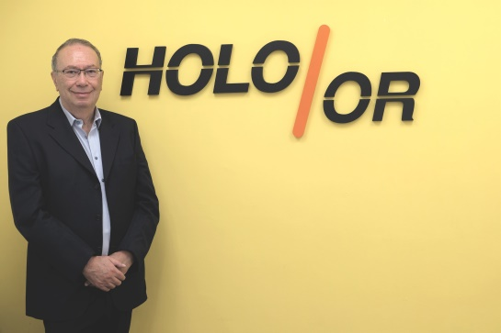
Diffractive optical elements (DOE) can be used to specifically shape laser beams. To achieve the ‘diffractive effect’, DOEs employ microstructures etched into a substrate using a lithographic process. Glass is typically the substrate – but plastics, metals or semiconductors can also be used. The Israeli company is regarded as an experienced player and leader in this market segment.

Founded by Israel Grossinger 31 years ago, HOLO/OR is one of only a few suppliers capable of producing DOEs, e.g. beam splitters and shapers, with high damage thresholds that can stand up to high-power lasers. Its expertise encompasses not just design and fabrication, but also a unique in-house simulation software.

Step-by-Step Integration
TechInvest Holding, the parent company of SCANLAB, acquired a quarter of all HOLO/OR shares in August 2020. Over coming years, the holding company will take over all remaining shares in several steps. The acquired company will retain its independence and collaborate closely with sister company SCANLAB on a number of projects. In addition to planned technical innovations, synergies in sales will also be achieved.

“I am very pleased in finding a suitable partner to whom I can gradually transfer responsibility for my company – and thereby entrust ‘my life’s work’ to good hands. As a founder and entrepreneur, one has not only responsibility for his team, but also a wish to see his vision carried forward. And this is exactly what our collaboration feels like,” states Israel Grossinger, Owner and President of HOLO/OR.
“Talks with the team in Israel were very constructive right from the beginning and driven by shared ideas. We’re convinced the gained optical expertise will result in a new generation of highly integrated scan systems,” says TechInvest Holding Executive Board Member Dirk Thomas in explaining the new investment’s advantages.

Print-quality images can be downloaded at
https://www.scanlab.de/en/news-events/image-library

About SCANLAB:
With over 35,000 systems produced annually, SCANLAB GmbH is the world-leading and independent OEM manufacturer of scan solutions for deflecting and positioning laser beams in three dimensions. Its exceptionally fast and precise high-performance galvanometer scanners, scan heads and scan systems find application in industrial materials processing and the electronics, food and beverage industries, as well as biotech and medical technology.
For 30 years, SCANLAB has secured its international technology leadership through pioneering developments in electronics, mechanics, optics and software, as well as the highest quality standards.

About HOLO/OR:
HOLO/OR Ltd., founded 1989 in Israel, develops, designs and manufactures diffractive optical elements (DOEs) and micro-optical elements. These components are being used for various applications mainly involving high precision and high-powered lasers.
Over the last three decades, HOLO/OR has gained considerable expertise in the design, simulation and manufacturing of DOEs, using its in-house software and tools.

Press Contact:
SCANLAB GmbH Phone +49 89 800 746-0
Ms. Eva Jubitz Fax +49 89 800 746-199
Siemensstr. 2a Email presse@scanlab.de
82178 Puchheim, Germany Internet www.scanlab.de

